**CSE3020 – Data Visualization**

**Project Report**

**Climate Change Visualization and Analysis**

*By*

20BCE1353 Siddharth S

B. Tech Computer Science and Engineering

*Submitted to*

**Dr. Joshan Athanesious**

**School of Computer Science and Engineering**



*April 2023*

**DECLARATION**

I hereby declare that the report titled “**Climate Change Visualization and Analysis”** submitted by me to VIT Chennai is a record of bona-fide work undertaken by me under the supervision of **Dr. Joshan Athenesious**, School of Computer Science and Engineering, Vellore Institute of Technology, Chennai.

Signature of the Candidate

**Siddharth S**

**Reg. No. 20BCE1353**

**ACKNOWLEDGEMENT**

We wish to express our sincere thanks and deep sense of gratitude to our project guide, **Dr. Joshan Athanesious,** School of Computer Science and Engineering, for his consistent encouragement and valuable guidance offered to us in a pleasant manner throughout the course of the project work.

We are extremely grateful to **Dr. Ganesan R,** Dean of School of Computer Science and Engineering, VIT Chennai, for extending the facilities of the School towards our project and for his unstinting support.

We express our thanks to our Head of the Department **Dr. Nithyanandam. P** for his support throughout the course of this project.

We also take this opportunity to thank all the faculty of the School for their support and their wisdom imparted to us throughout the course.

We thank our parents, family, and friends for bearing with us throughout the course of our project and for the opportunity they provided us in undergoing this course in such a prestigious institution.

**ABSTRACT**

Climate change is one of the most pressing global challenges facing humanity today. It has been caused by human activities, such as the burning of fossil fuels, deforestation, and industrial processes, which have released large amounts of greenhouse gases into the atmosphere. These gases trap heat and cause the Earth's temperature to rise, resulting in a range of adverse effects, including more frequent and severe weather events, sea-level rise, and changes in ecosystems. The importance of tackling climate change cannot be overstated. Its impacts are already being felt around the world, from the devastating wildfires in Australia, to the hurricanes that have ravaged the Caribbean and the United States, to the droughts and floods that are affecting communities in Africa and Asia. Climate change threatens the basic needs of life, such as food, water, and shelter, and exacerbates existing social and economic inequalities. Visualizing trends related to climate change is crucial for understanding the severity of the problem and developing effective solutions. Climate data is complex and difficult to understand, but through the use of visualizations, it can be made more accessible and meaningful to a wider audience. Visualizations can help to highlight the scale and urgency of the problem, and show how different regions and communities are being affected in different ways. They can also help to communicate complex scientific concepts, such as the relationship between greenhouse gas emissions and global temperature rise, in a clear and intuitive way. Furthermore, visualizing trends related to climate change can help to inform decision-making at all levels. Policymakers, businesses, and individuals need to understand how climate change will affect their operations and daily lives, and what actions they can take to reduce their impact. By making climate data more accessible and understandable, visualizations can help to identify areas where action is needed, and track the progress of mitigation and adaptation efforts.

**TABLE OF CONTENTS**

1. Introduction 1

1.1. Objective and Goal of the Project 1

1.2. Motivation 1

1.3. Challenges 1

2. Literature Survey 2

3. Requirements Specification 5

3.1. Software Requirements 5

3.2. Hardware Requirements 5

4. System design and methodology 6

5. Results and Discussion 9

6. Conclusion and Future Work 21

7. References 22

1. **Introduction**
   1. **Objective and Goal of the Project**

This project aims to develop a comprehensive set of data visualizations and analytical conclusions that enable users to explore the impacts of climate change on the planet. The project will leverage a variety of data sources, like temperature and climate data, to create interactive visualizations that allow users to explore climate change trends over time and across different regions. By providing accessible and intuitive visualizations and analysis, this project will help individuals and policymakers better understand the complex and urgent issue of climate change, and develop strategies to mitigate its impacts.

* 1. **Motivation**

Climate change is a global challenge that affects everyone, and it has significant social, economic, and environmental consequences. Understanding the causes, impacts, and potential solutions to climate change is critical to ensure a sustainable future for our planet and future generations. By analyzing climate change, individuals can contribute to the development of effective solutions and strategies to mitigate its impacts. It requires a multidisciplinary approach and expertise in the field to accurately analyze the causes and effects of it. By working to understand and address climate change, individuals can contribute to a larger mission of protecting the planet and ensuring a sustainable future for all. This sense of purpose can be a powerful motivator for those who are passionate about the environment and want to make a difference in the world.

* 1. **Challenges**

The primary challenges faced in the planning and implementation of this project come down to the public availability of data and the legitimacy and accuracy of the data. It is easy to get lost in extremely large datasets that are raw data that come straight from a monitoring station, which requires to be processed for any meaningful conclusions to be made.

1. **Literature Survey**

Climate change is one of the most significant challenges facing humanity in the 21st century. It is a complex and multifaceted issue that affects every aspect of human life, from food and water security to energy systems and public health. Climate change analysis plays a critical role in our understanding of the causes and impacts of climate change, as well as in the development of effective strategies for mitigating and adapting to its effects. The field of climate change analysis is constantly evolving, with new data, models, and methods emerging to improve out understanding of this complex phenomenon.

Some conventional climate change mitigation strategies which specifically look at carbon are outlined in [1], which are renewable energy, nuclear power, carbon capture, storage and utilization, and fuel switch and efficiency gains. The prominent renewable energy sources include solar power, onshore and offshore wind power, hydropower, marine power, geothermal power, biomass power and biofuels. Nuclear energy is considered a low carbon solution for climate change mitigation; however, it does come with risks of radiation pollution and nuclear wastes which pollute the atmosphere and water bodies. Carbon capture and storage is a promising technology which aims to capture CO2 gases from processes that rely on fossil fuels, which is then stored and used for different purposes. The second prong that is outlined in [1] are negative emissions technologies, which are ways in which carbon is captured and sequestered from the atmosphere. This includes bioenergy carbon capture and storage, afforestation and reforestation, biochar, soil carbon sequestration, enhanced terrestrial weathering, wetland restoration and construction, direct air carbon capture and storage, ocean alkalinity enhancement and ocean fertilization.

Some more novel and technical approaches to finding a solution to climate change is suggested, where machine learning algorithms can be used in the creation of systems to reduce the emissions that lead to climate change [2]. Several factors are tackled at once, like enabling low carbon electricity, transportation, building and cities, industries, farms, etc. In the generation of electricity, it is suggested to use ML models to optimize the sources of electricity, by forecasting supply and demand. Domain specific models are suggested to further optimize energy consumption. This allows improvements to scheduling and allows for a flexible demand. ML also has the potential to accelerate material science, through which perhaps cleaner sources of energy can be discovered and made viable. In the transportation category, four main strategies are outlined to reduce greenhouse gas emissions: reducing transport activity, improving vehicle efficiency, alternative fuels and electrification of vehicles, and model shift to lower carbon modes of travel. Electric vehicles are just on the rise and to ensure the proper operation of an electric vehicle, especially as it is an emerging market, insights that you gain from ML and data analytics will prove to be very useful in improving user experience and convincing users to switch to electric instead of traditional gas cars. Efficiency of vehicles are also improved through the use of ML models to ascertain the most aerodynamic shapes, engine configuration, weight balance, tires, etc. ML also improves understanding about people’s travel mode choices, through which optimizations can be made to cleaner sources of travel like rail and public transport, to incentivize greater use of these facilities. Optimization models can also help with the design of buildings, both exterior and interior, like for optimizing lighting inside a building. Similarly, ML has a lot of applications that allow for improving materials in the industry, supply chain improvements, and other applications in agriculture.

In improving climate change data visualization, insights can be taken from cognitive and psychological science [3]. It is suggested that sensory processes direct human eyes to specific features of a graphic or visualization. Features that are visually salient like color, shape and size can draw the attention of the viewer, and this is known as bottom-up visual processing. Top-down visual processing is when the viewer has expectations driven by previous knowledge or experience. It is also highlighted that intuitive design does not always equal improved accessibility. Graphic features like realistic features, 3D features and extraneous variables in data can impair comprehension, which is not something that is usually considered during the making of a visualization by an expert. In a similar vein, [3] points out that accessibility does not equal loss of scientific rigor. To understand the details of a graphic, we use our central vision, afforded by the fovea centralis, which provides greater acuity than our peripheral vision. The visual field of this is approximately two degrees of visual angle in diameter. When visualizing data, we move our eye gaze to sample information from different spatial locations and to build a detailed representation of the graphic as a whole, we encode and retain information from these different spatial locations in memory. Keeping this in mind, directing visual attention to important details can therefore make graphics more accessible by supporting viewers to look at aspects of the graphic that afford understanding. This directing of attention can be done by the use of arrows, or pointing gestures. Top-down processing can be made to use by giving the reader expectations of what to look for in the visualization, which can greatly affect the perception of a visualization. Likewise, complexity in the data and visualization should be handled and the core part of the data should not be overly complex. The visualization should support inference making and use text to support cognition and perception. Lastly, graphics are to be tailored to different audiences. For example, graphics that are made to be shown to a panel of well-informed scientists are to be made in a more complex and intelligent way compared to that same data when it has to be visualized for the common person.

[4] proposes a machine learning based tool that, in a personalized way, shows the probable effect that climate change will have on a specific location familiar to the viewer. This is done with the aim that such visualizations would help visceralize climate change to the average person; they might be more inclined to help out and take action when seeing the consequences of climate change on their home, their neighborhood, or the street t hat they grew up on. This is achieved by training a CycleGAN network on Google Street View images of both flooded and unflooded streets and houses. This model is then in turn able to learn an adequate mapping between grass and water, which would help create fairly realistic looking images of flooded houses. A binary flood map is also proposed which helps build the realism of this model, as it would not make sense that a house in the middle of a desert would be flooded due to rising sea levels. This model would, as the authors in [4] put it, allow users to visually see the impact of their personal choices, such as deciding to use more public transportation, as well as the impact of broader policy decisions, such as carbon tax [4] and increasing renewable portfolio standards.

For the real time monitoring and visualization of greenhouse gas emissions, a cyber physical system-based approach can be utilized from prefabrication sites based on the analysis and comparison of previous GHG emission assessment methods [5]. First, through the analysis of the GHG emissions of a prefabrication site, the system boundary was defined to limit the research scope to GHG emissions generated by machineries in construction sites. As a preliminary attempt, three types of machinery commonly used in the engineering of the main structure in a construction site were selected, namely, tower cranes, construction elevators, and transfer vehicles. These machineries were used to establish the GHG emission calculation model and determine the corresponding GHG emission factors to determine the calculation logic of the CPS-based system. Thereafter, the entire framework of the CPS-based system was constructed, the functions and interactions of each part were designed, and the specific development process of each part was described.

[6] describes a novel combination of modern mapping technologies, with which this study develops an online mapping application of air quality of China. In this study, an open web platform is fully used to collect the time series air quality data consistently. Then, data visualization tools (D3.js) and web mapping tools (leaflet.js, rbush.js) are well combined to produce a fine interactive mapping application of spatio-temporal data. From the application, we can get a whole view of the air quality condition of China at a nationwide scale and a year time span at multiple spatio-temporal granularities. This interactive map application clearly presents several significant findings of air quality in China, which provide good assistance for visual air quality analysis and clues for in-depth studies on air pollution. There are three key takeaways which are that there are more and more open data about the living environment, and that we should make full use of new technologies for data visualization, and that the visual form of data is more expressive than the raw data table [6]. This shows the importance of visualization of data in gaining inferences and identifying solutions to any problem.

1. **Requirements Specification**
   1. **Software:**

Jupyter Notebook

Python 3

Python modules:

* datetime
* pandas
* numpy
* seaborn
* matplotlib
* plotly
* statsmodel
  1. **Hardware:**

Operating System: Windows, MacOS or Linux

CPU: Intel/AMD Dual Core or greater

RAM: 8GB or greater

Storage: 1GB or greater

1. **System Design and Methodology**

This project has made use of various visualization tools to create interactive and dynamic plots. In general, before visualizing any factor, data preparation has to be done, wherein the data is described and anomalies are filtered out (like empty values or outliers). This allows for a cleaner visualization and maintains the accuracy of the plots and analysis that is derived from it.

Several popular data visualization libraries in Python were used for the plots, most notably plotly, which is an open-source graphing library that is very useful for creating interactive and dynamic plots of data. Additional libraries include seaborn and matplotlib which are great for static plots and analysis. For data manipulation, pandas and numpy were used.

For visualizing climate change, this project looks at four related effects that come directly as a result or directly cause climate change. These are: Temperature, Air Quality, Greenhouse Gas Emissions and Sea Level.

1. **Temperature:**

The Earth's temperature is determined by the balance between the amount of heat that comes into the atmosphere from the sun and the amount of heat that is radiated back into space. This balance is influenced by factors such as the composition of the atmosphere, the reflectivity of the Earth's surface, and the amount of greenhouse gases in the atmosphere. Over the last century, we have observed a continuous increase in global average temperatures, and this long-term increase in the Earth’s average surface temperature is referred to as global warming. This has been caused due to human activities like the burning of fossil fuels that have led to an increase in the concentration of greenhouse gases in the atmosphere, which effectively trap the heat of the sun within the Earth’s atmosphere.

1. **Air Quality:**

Air Quality is the degree to which the air is suitable or clean enough for humans or the environment. Climate change can have a direct impact on air quality through changes in temperature, precipitation, and weather patterns. Higher temperatures can increase the formation of ground-level ozone, a major component of smog, while changes in precipitation can affect the dispersion of air pollutants. More frequent and severe weather events, such as wildfires and dust storms, can also lead to poor air quality. On the other hand, poor air quality can also contribute to climate change. Air pollution from sources such as burning fossil fuels and industrial processes can release greenhouse gases, such as carbon dioxide and methane, into the atmosphere. This can lead to a feedback loop, where poor air quality exacerbates climate change, which in turn leads to even poorer air quality. Air quality is commonly measured and reported with respect to an Air Quality Index (AQI), which takes five major air pollutants into account: ground level ozone, particulate matter, carbon monoxide, sulfur dioxide, and nitrogen dioxide.

1. **Greenhouse Gas Emissions:**

Greenhouse gases are gases in the Earth's atmosphere that trap heat and contribute to the greenhouse effect. They include gases such as carbon dioxide (CO2), methane (CH4), nitrous oxide (N2O), and fluorinated gases, such as hydrofluorocarbons (HFCs) and sulfur hexafluoride (SF6). The greenhouse effect is a natural process by which some of the energy from the sun that reaches the Earth's surface is absorbed and then re-emitted back into the atmosphere as heat. Greenhouse gases in the atmosphere trap some of this heat, keeping the Earth's surface warm enough to support life. However, the increasing concentration of greenhouse gases in the atmosphere, primarily from human activities such as burning fossil fuels, deforestation, and agriculture, is causing the Earth's temperature to rise. This rise in temperature, known as global warming, is causing changes in the Earth's climate, such as melting glaciers, rising sea levels, and more frequent and severe weather events.

1. **Sea Level:**

Sea level refers to the average level of the ocean's surface. It is measured relative to a fixed point on land, known as a datum. Sea level has been rising steadily over the past century, and the rate of rise has been accelerating in recent decades. According to the Intergovernmental Panel on Climate Change (IPCC), global sea level has risen by approximately 15 cm (6 inches) since the beginning of the 20th century, and is projected to rise by another 30-110 cm (12-43 inches) by the end of the 21st century, depending on future greenhouse gas emissions and other factors. The primary cause of sea level rise is the thermal expansion of seawater, which occurs as the ocean absorbs heat from the atmosphere. As the water warms, it expands, causing the sea level to rise. This process has been responsible for approximately half of the observed sea level rise over the past century. Another major cause of sea level rise is the melting of land-based ice, such as glaciers and ice sheets in Greenland and Antarctica. As these ice masses melt, they add water to the ocean, causing the sea level to rise. This process has become an increasingly important contributor to sea level rise in recent decades. Sea level rise has numerous impacts, including increased flooding and erosion along coastlines, saltwater intrusion into coastal aquifers, and the displacement of coastal populations. Rising sea levels also exacerbate the impacts of storm surges and coastal flooding events, which can cause significant damage to infrastructure and property.

Multiple datasets for each of these categories were obtained from Kaggle, containing both time series and cross-sectional data.

The plots used are

1. Barplot:

A bar plot, also known as a bar chart or bar graph, is a graphical representation of data in which rectangular bars are used to represent the magnitude of the variables being compared. The height or length of each bar corresponds to the value of the variable being represented. Bar plots are commonly used to compare the sizes of different categories or groups of data, and they are particularly useful when comparing data across multiple time periods, regions, or other variables. They can also be used to display patterns or trends in data over time or across different categories.

1. Line plot for time series data:

A line plot is a type of chart that displays data as a series of points connected by a straight line. Line plots are used to visualize trends or patterns in data over time or across different categories. In a line plot, the x-axis represents the independent variable, such as time, and the y-axis represents the dependent variable, such as the value of a stock or the number of visits to a website. Each data point represents a single observation or measurement of the variable, and the points are connected by a line to show how the value of the variable changes over time or across categories.

1. Interactive polar plots for multidimensional time series data:

A polar plot is a type of graph that displays data in a two-dimensional circular format. Polar plots are used to visualize data that is represented by two variables, usually an angle and a radius. In a polar plot, the angle is plotted on the x-axis, and the radius is plotted on the y-axis. The data points are then plotted on the graph, with the radius indicating the value of the dependent variable, and the angle indicating the independent variable. The points are connected by a line or curve to show the relationship between the variables.

1. Choropleth plots for visualizing regions on a global map:

A choropleth map, also known as a shaded map or thematic map, is a type of map that uses colors or shading to represent the spatial distribution of a particular variable or set of data across a geographic area. The variable being represented is typically a statistical measure, such as population density, per capita income, or election results. In a choropleth map, the geographic area being studied is divided into smaller regions, such as counties, states, or countries. Each region is then colored or shaded according to the value of the variable being represented. Regions with higher values are usually colored in darker shades, while regions with lower values are colored in lighter shades.

1. Heatmap:

A heatmap is a graphical representation of data that uses colors to represent the magnitude of a variable or set of variables. Heatmaps are often used to visualize large amounts of data and to identify patterns or relationships between variables. In a heatmap, data values are represented as colors, with the intensity of the color indicating the magnitude of the value. Typically, warmer colors such as red or orange represent higher values, while cooler colors such as blue or green represent lower values. Heatmaps can be two-dimensional, with the data values displayed in a grid or matrix, or three-dimensional, with the data values displayed on a surface.

1. **Results and Discussion**
2. **Temperature**

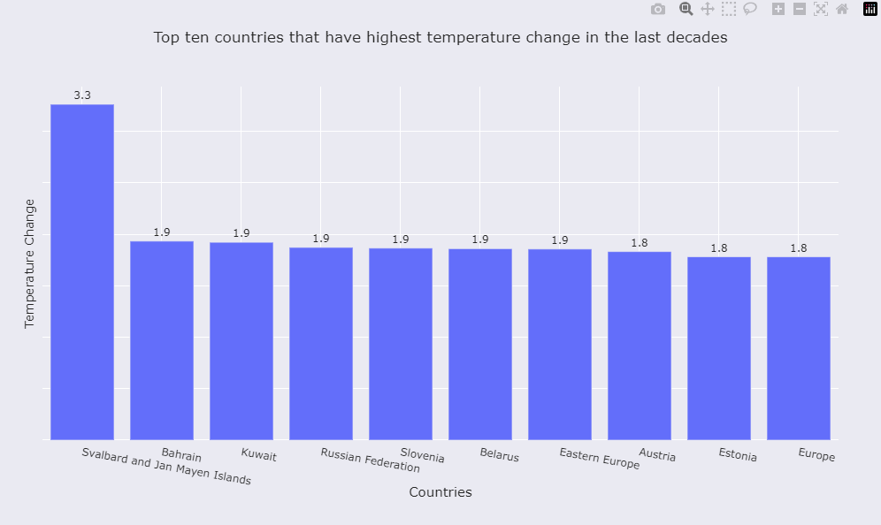

From our first plot, we infer that in the last decade, some notable countries that have had the highest increase in temperature are Bahrain, Kuwait, and Russia. Bahrain and Kuwait saw rapid urbanization in the last decade, and being countries in the Arabian peninsula, they suffer from water scarcity which contributes to higher temperatures. Additionally, all the top three regions (Bahrain, Kuwait and Russia) contain a lot of oil and gas industries which leads to a significant emission of greenhouse gases, which consequently leads to a higher increase in temperature.

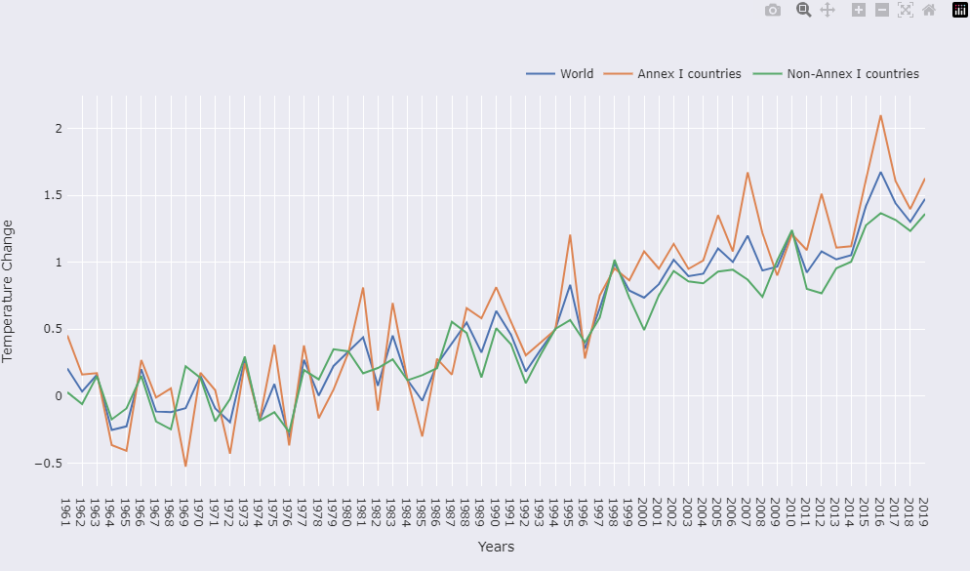

Between 1961 and 2019, there is a general trend that Annex 1 countries (developed countries) saw a greater increase year over year in the average temperature compared to Annex 2 (non developed countries). This can be due to the fact that developed countries are responsible for a greater share of greenhouse gas emissions which is a primary factor that affects global warming.

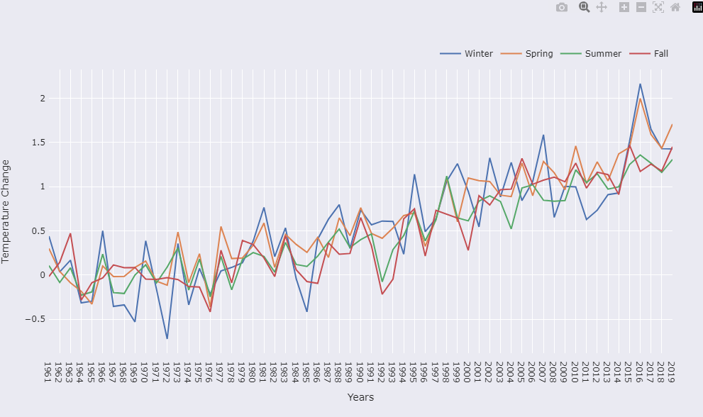

Similarly by plotting the line graph for each season, we can observe a general upward trend in the increase in temperature across all seasons.

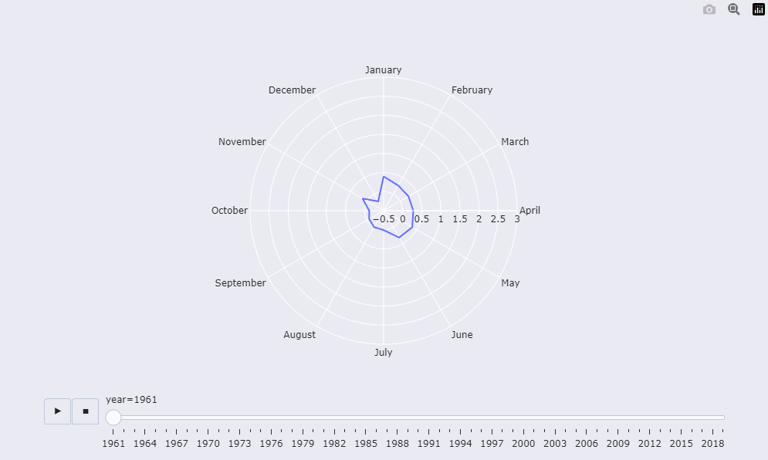

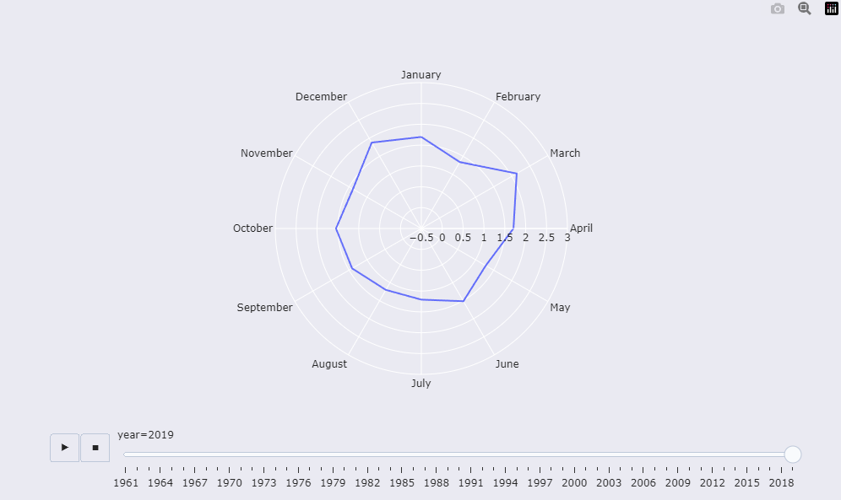

This polar graph shows an interactive animation that depicts the increase in the change of temperatures year over year for each month. As is inferred from the plot, in 2019 there was a much greater increase in temperature from 2018, as compared to 1961. This is primarily due to rapid industrialization which occurred during the 20th century, the effects of which is being felt now through the yearly rise of temperatures.

This same conclusion is also visualized in a choropleth, which visualizes the data for each country on a human readable map.

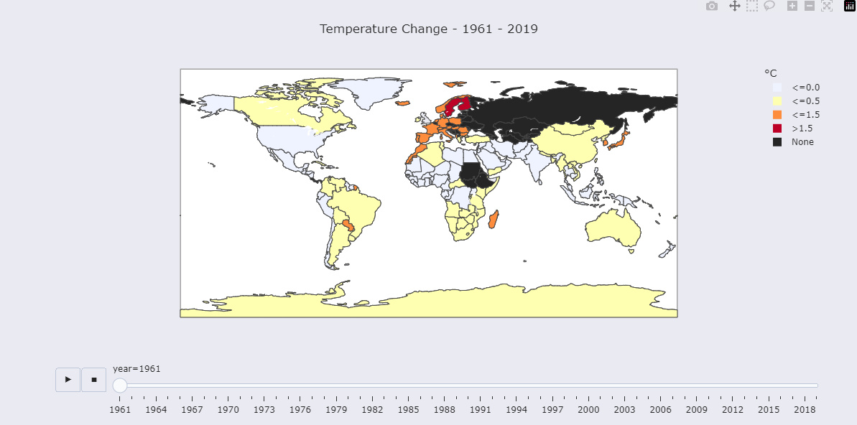

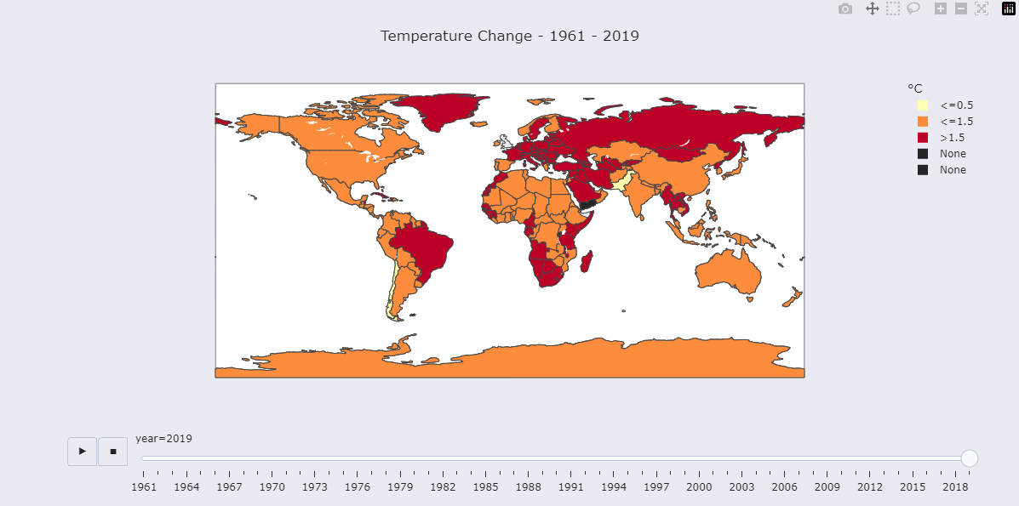

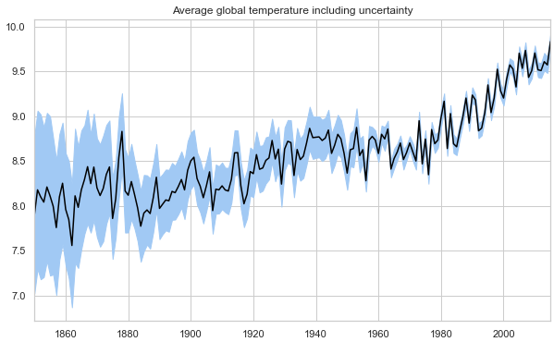

When looking at average temperatures for the whole planet, we observe a clear upwards trend from the 1800s to present day.

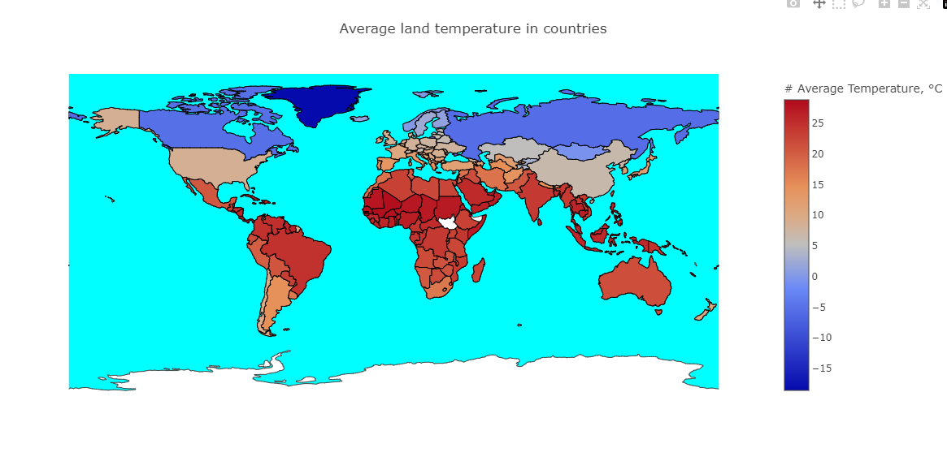

From this choropleth, the hotter and cooler regions of the world are visualized. Areas in South America, Africa, and South and South East Asia record higher average temperatures while northern regions like North America and Russia have lower average temperatures. In general, countries in the northern hemisphere experience cooler temperatures while countries near the equator and in the southern hemisphere experience warmer temperatures. This is because the Northern Hemisphere has a greater amount of landmass compared to the Southern Hemisphere, and landmasses tend to heat up and cool down more quickly than oceans. In addition, the Northern Hemisphere has a greater proportion of its landmass located at higher latitudes, where temperatures tend to be colder due to the angle of the sun's rays and the amount of daylight.

1. **Air Quality**

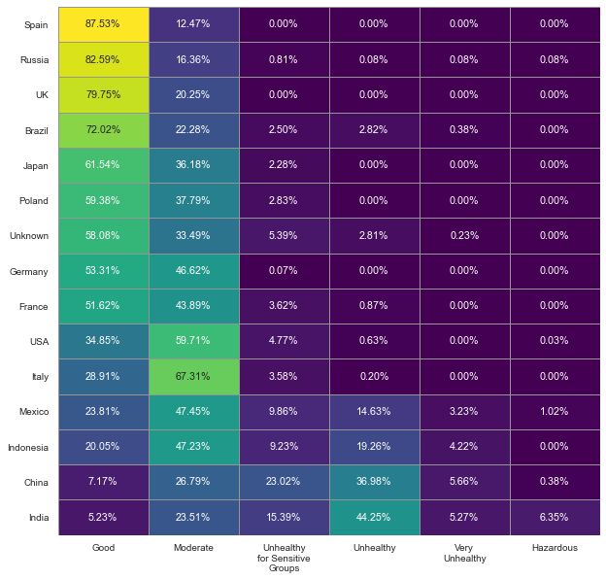

This heatmap shows the quality of air based on the percentage of the measured air quality. For instance, Spain has the best outlook from this visualization as 87.53% of all recordings from Spain are of Good Air Quality Index. India on the other hand has most of their measurements at "Unhealthy" levels of AQI.

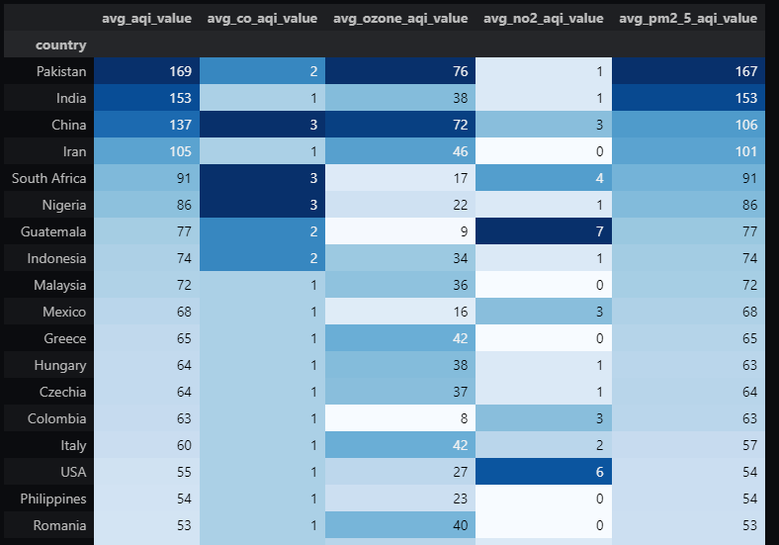

Pakistan, India and China are the top three countries with the worst average AQI value as reported. This is due to a few factors like: 1. Industrial pollution, where, due to a large number and emergence of production industries and power plants, there is a high level of air pollution from them. 2. Vehicle emissions are extremely high due to a high percentage of the population of these countries owning motor vehicles, due to poor development of public transport. 3. Agricultural practices like burning of crops also plays a role into air pollution.

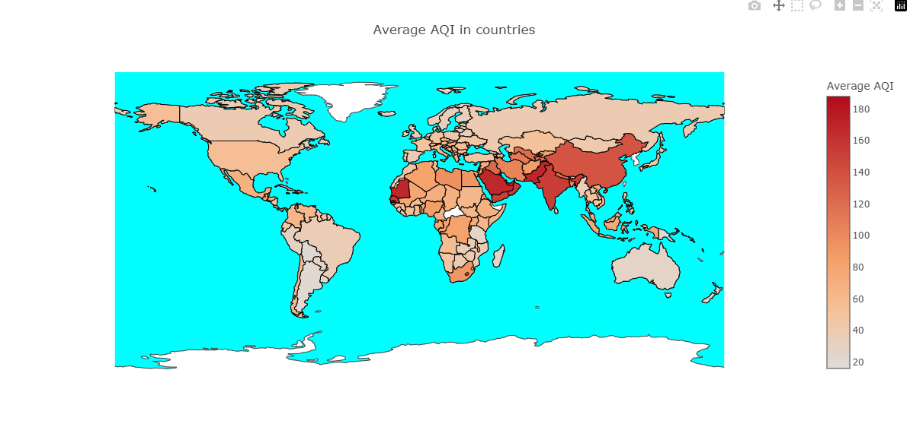

The average Air Quality is now visualized in a Choropleth and it is indeed confirmed that Pakistan and India along with some of the middle eastern countries have the worst recorded AQI values.

1. **Greenhouse Gases**

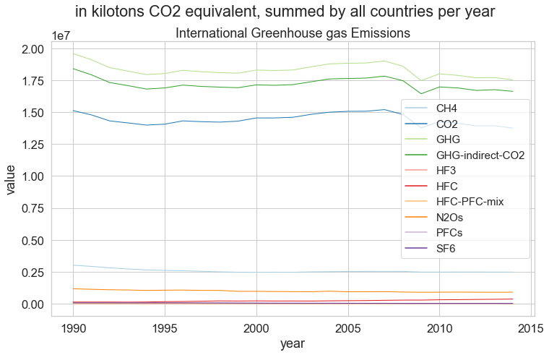

Looking at greenhouse gases, we observe a general downward trend in the emissions of greenhouse gases due to more environmental awareness and products designed taking environmental restrictions into account.

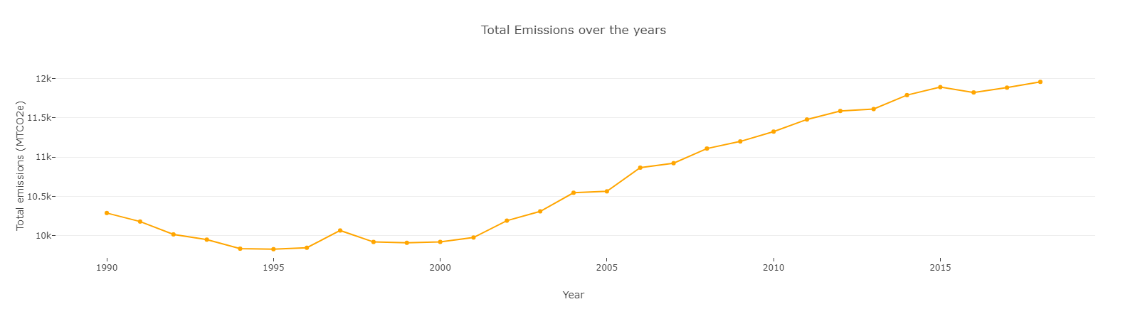

When looking specifically at methane emissions across all sectors, we observe an upwards trend. This is also visualized in an interactive choropleth

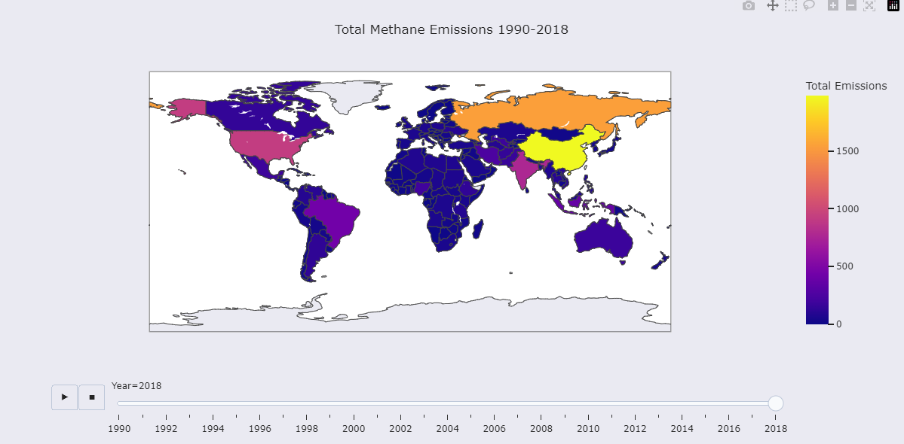

China, Russia and the US account for most of methane emissions, once again owing to their large populations, high levels of economic activity, and dependence on fossil fuels and livestock production. Coal, oil and natural gas together account for being the source of 80% of the total energy produced in India, for example. This production process emits a large amount of methane into the atmosphere.

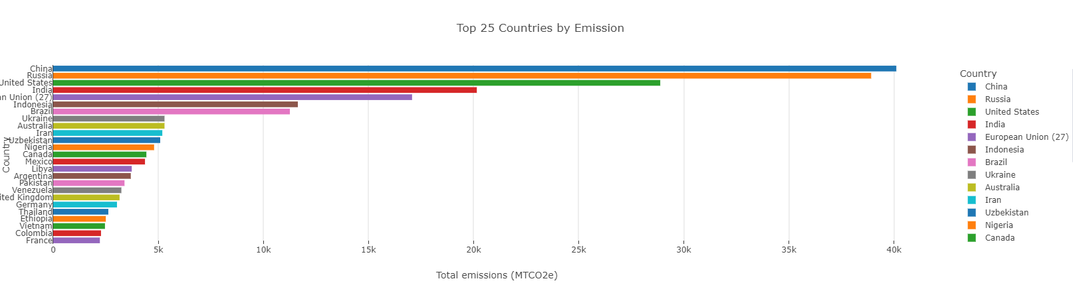

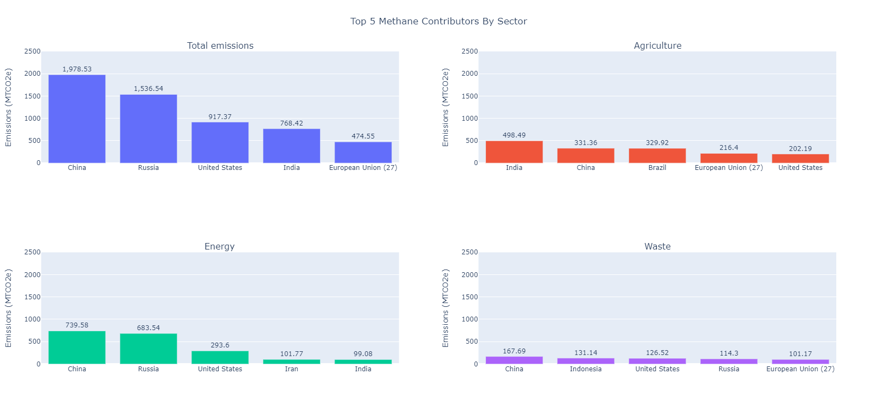 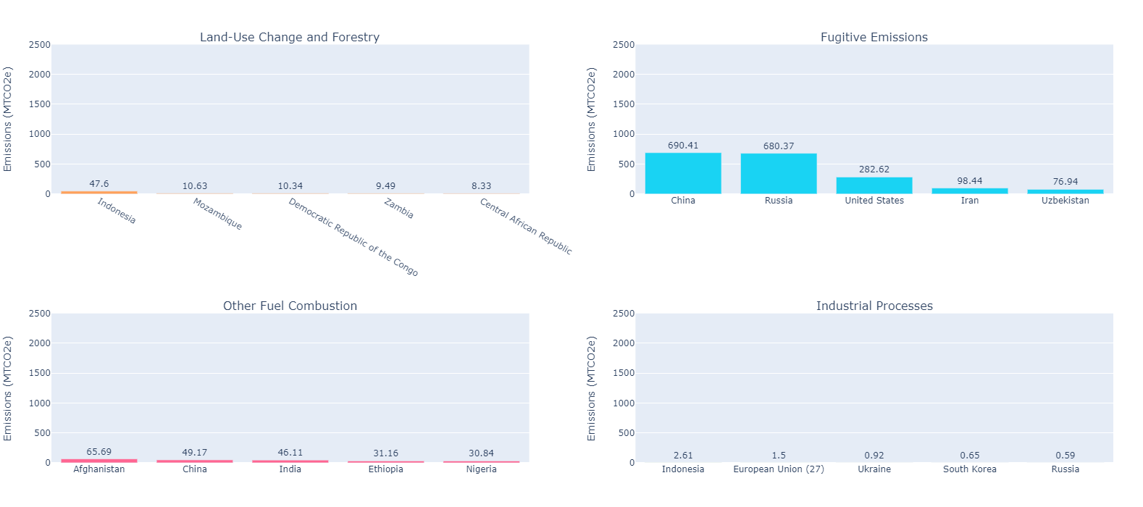

The agriculture and energy sectors are responsible for most of the methane emissions.

In the agricultural sector, the sources of methane are: Enteric fermentation i.e. the process of digestion for a lot of farm animals like cattle produces a lot of methane. Methane is also produced in the decomposition of manure in storage facilities. Some synthetic fertilizers also cause methane emissions in the production and usage of said fertilizers.

In the energy sector, Methane is released during the extraction and processing of fossil fuels such as coal, oil, and natural gas. Coal mining operations can release methane that has been trapped in coal seams. Methane can also be released during the extraction of oil and natural gas, both from conventional sources and from shale gas formations through hydraulic fracturing or "fracking" processes. It is also released in the burning of biomass like wood, crop residues, and animal waste.

1. **Sea Level**

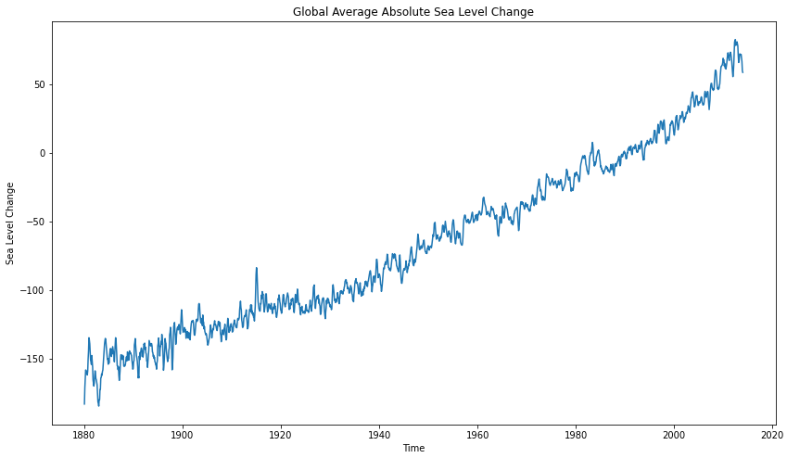

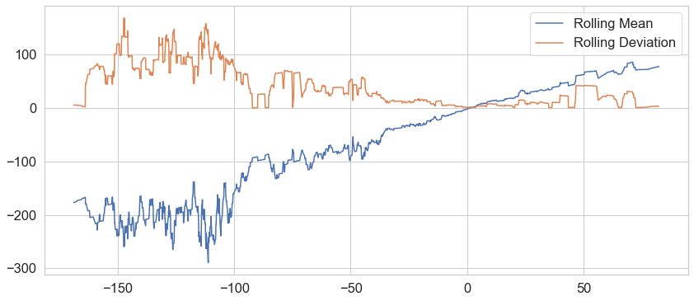

Lastly, when looking at sea levels, we observe an increase in the sea levels from 1880 to 2020. This is due to the global temperature increases which causes the salt water in oceans to undergo thermal expansion. Additionally, the melting of land based ice, like glaciers and ice sheets also contributes to contributes to the rising sea level.

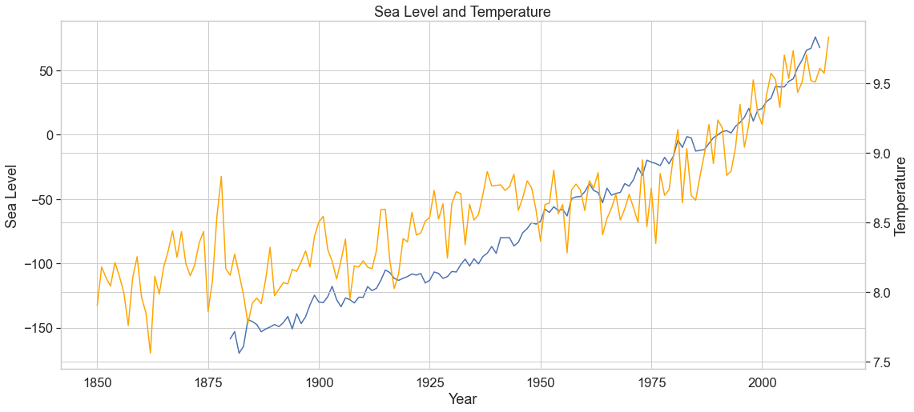

We can verify this by plotting both global temperatures and sea level changes in the same plot for the same time period. Here, we do see the correlation between the two.

1. **Conclusion and Future Work**

In conclusion, this project has demonstrated some of the factors that are attributed to climate change, and how they have changed over the years. From all this data and by visualizing it, the average person is able to understand that yes, climate change is indeed real and has been happening for decades. It is only of big importance in recent years due to the Earth being at its tipping point when it comes to sustaining human life, and also the rise of environmentalists from the newer generations who understand the need for preserving the planet we call home. It is also important to realize that the factors consisting of climate change are not independent of each other. For example, the rise in sea levels is due to rising temperatures, which in turn is due to the increased greenhouse gas emissions in the atmosphere which is trapping heat from the sun. These are also problems that affect the whole planet, which is a scale of problem that demands careful consideration and planning, and a lot of patience to solve.

There has been a huge shift in the mindset of people regarding climate issues over the last couple of decades, and strides are being taken to making the planet greener and cleaner which will directly retard the rate of climate change. Some of these measures are: the push to more renewable sources of energy like solar and wind, the use of more recyclable materials in the manufacturing and packaging of products, and the collaborative effort of people and governments around the world.

This project can be expanded on by integrating forecasting models, to provide more insight into where we’re headed if we do not do anything to combat climate change. Additionally, more information can be brought like global precipitation data, assuming a reliable source for this data is freely available to use.

The full project code can be found at:

<https://github.com/witeeeee/Climate-Change-Visualization>

1. **References**

[1] Fawzy, S., Osman, A.I., Doran, J. et al. Strategies for mitigation of climate change: a review. Environ Chem Lett 18, 2069–2094 (2020). <https://doi.org/10.1007/s10311-020-01059-w>

[2] David Rolnick, Priya L. Donti, Lynn H. Kaack, Kelly Kochanski, Alexandre Lacoste, Kris Sankaran, Andrew Slavin Ross, Nikola Milojevic-Dupont, Natasha Jaques, Anna Waldman-Brown, Alexandra Sasha Luccioni, Tegan Maharaj, Evan D. Sherwin, S. Karthik Mukkavilli, Konrad P. Kording, Carla P. Gomes, Andrew Y. Ng, Demis Hassabis, John C. Platt, Felix Creutzig, Jennifer Chayes, and Yoshua Bengio. 2022. Tackling Climate Change with Machine Learning. ACM Comput. Surv. 55, 2, Article 42 (February 2023), 96 pages. <https://doi.org/10.1145/3485128>

[3] Nordhaus, William Climate Change: The Ultimate Challenge for Economics American Economic Review 109 6 1991-2014 2019 10.1257/aer.109.6.1991 <https://www.aeaweb.org/articles?id=10.1257/aer.109.6.1991>

[4] Victor Schmidt and Alexandra Luccioni and S. Karthik Mukkavilli and Narmada Balasooriya and Kris Sankaran and Jennifer Chayes and Yoshua Bengio. 2019. Visualizing the Consequences of Climate Change Using Cycle-Consistent Adversarial Networks arXiv:1905.03709 <https://doi.org/10.48550/arXiv.1905.03709>

[5] Guiwen Liu, Hao Yang, Yan Fu, Chao Mao, Pengpeng Xu, Jingke Hong, Rongyan Li, Cyber-physical system-based real-time monitoring and visualization of greenhouse gas emissions of prefabricated construction, Journal of Cleaner Production, Volume 246, 2020, 119059, ISSN 0959-6526, <https://doi.org/10.1016/j.jclepro.2019.119059>

[6] Lu, Wei, Tinghua Ai, Xiang Zhang, and Yakun He. 2017. "An Interactive Web Mapping Visualization of Urban Air Quality Monitoring Data of China" Atmosphere 8, no. 8: 148. <https://doi.org/10.3390/atmos8080148>